**Robertson Creek Chinook fecundity sampling**

**OVERVIEW AND WORKPLAN**

**Objective**

Update the Somass Chinook escapement target to ensure Robertson Creek Hatchery has the necessary contingency to meet its broodstock target. Current escapement target of 21,000 is based on historical fecundities that are known to be too high. This study will update the biostandards for fecundity at age in 3, 4, and 5 year old females. Considering the focus on the hatchery’s broodstock target, the study will estimate “realized” fecundity, *i.e.* the number of eggs females yield to the hatchery. Females lose eggs during migration owing to stressors such as low water flows and high water temperatures, and during broodstock collection owing to handling stress. It is not the objective of this study to estimate “potential” fecundity, *i.e.* the number of eggs attached to the skein prior to any loss during migration, although observations on apparent levels of egg loss will be noted during sampling.

**Logistics**

1. Timeframe and personnel. Chinook start showing up at the hatchery by late-Sept/early-Oct with good rains. Egg takes start around mid-Oct. Most Chinook are dead by 23 Oct. Last year it spanned 6–20 Oct. So the effective period for the study is 3 weeks through the middle of October. Reasons to spread fecundity sampling across the full three weeks: egg viability is likely lower later in the run, three year old females—the constraining age in this study owing to their rarity—*might* be more prevalent earlier. Reason to conduct the study over a shorter time period: samplers will be less rushed if the bulk of broodstock takes are finished prior to this study. The hatchery’s spawning days are 3–4 per week.
   1. Compromise: sample during the first week with a lower target to hopefully intercept a few 3 year old females and then increase the sample targets for the latter two weeks. So, fecundity sampling will proceed for 1 day on first week and 2 days per week during last two weeks. (**Action:** Nick to coordinate with Steve & Graeme to settle on dates for the sampling and then prepare a sign-up sheet/schedule for distribution).
   2. Required personnel will be two per sampling day. The hatchery can spare one person, one day per week for three weeks. If the sampling can be coordinated well with deadpitch sampling, StAD/Hup techs could participate as well. (**Action:** Nick/Pat/Jeff to arrange a separate call to coordinate deadpitch sampling and staffing, tie in the work with the fecundity sampling). Michael Thom would also like to join for at least one day.
2. Subject females will be sampled from the broodstock takes. This is to address the main objective of the study (see above), and to make efficient use of sampling supplies and personnel. The drawback of sampling eggs prior to their use for spawning is increased egg mortality of up to 50%. However, considering the target sample size (see below), this should expose no more than 5% of the eggs to the increased mortality risk.
3. A Gravimetric sampling methodology will be applied to estimate the fecundities of individual females. The total wet egg mass from each female will be weighed, and then a 300-g (wet weight) subsample of eggs will be enumerated. The resulting count will be expanded according to the total weight of the egg mass.
4. Data collected from females will be the same as that collected during the routine broodstock program. In addition, the females selected for fecundity sampling will be assigned a unique ID that pairs their data to the egg counts. (**Action:** hatchery staff/SEP to send Nick a copy of the current broodstock data sheets, Nick to ask Karin about uniquely numbered coloured zip ties, working group to determine how to qualitatively classify % egg retention). Egg data will be recorded on separate datasheets. The egg datasheets will include: notes on suspected level of egg loss in sampled fish, total egg mass weight, weight of the ≈300-g subsample, egg count of the 300-g subsample, and length of 10 eggs selected randomly from the 300-g subsampled and aligned together on a juvenile egg measuring board. (**Action:** Jeff to develop template data sheet for egg data). All sampling supplies will be supplied by the hatchery. (**Action:** Nick/Jeff to provide list of required materials to Steve and Graeme).

**Target sample**

Power analysis (see Appendix, below) suggests 14 females per age class should allow estimation of mean fecundities with sufficient accuracy. However, ages won’t be known at time of sampling. Mean POH lengths at age are 621,706, 758 for 3, 4, and 5 year olds, respectively, with considerable overlap between ages (see histogram in Appendix, below). Thus, target sample sizes within length bins will need to be developed to maximize the probability of meeting sample size required from each age. (**Action**: Nick to reach out for statistical advice and/or research a method to apply probability theory and produce a recommended sample size target by POH length). As an upper bound on sample size, the hatchery can afford 200 females on a *good* run. Suggestion is to start with 100 and possibly adjust upward if the sex ratio looks favourable for a relative abundance of returning females.

**Other considerations**

* Untagged jacks will be returning this year
* Thermal marks are missing on the 2018 brood year (3 year old females)
* There was an unassociated fed fry release in 2016 due to an infrastructure malfunction in April. So, CWT expansions for escapement will be biased low in terms of ACTUAL enhanced contribution (as well as enhanced catch). Need to use thermal marks. Can this be rectified by MRP?

**APPENDIX**

Power analysis results indicate minimum sample of 14 females per age class for 80% power to estimate mean fecundities:

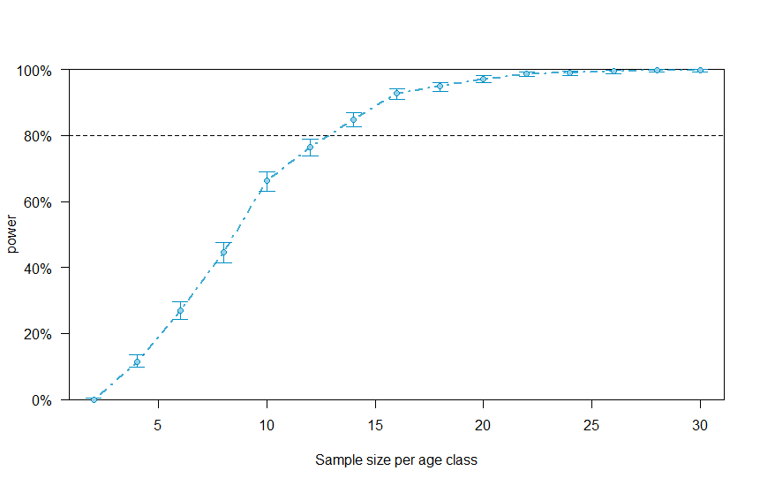

Precision curves suggest how confidence intervals will shrink with increasing sample size per age class:

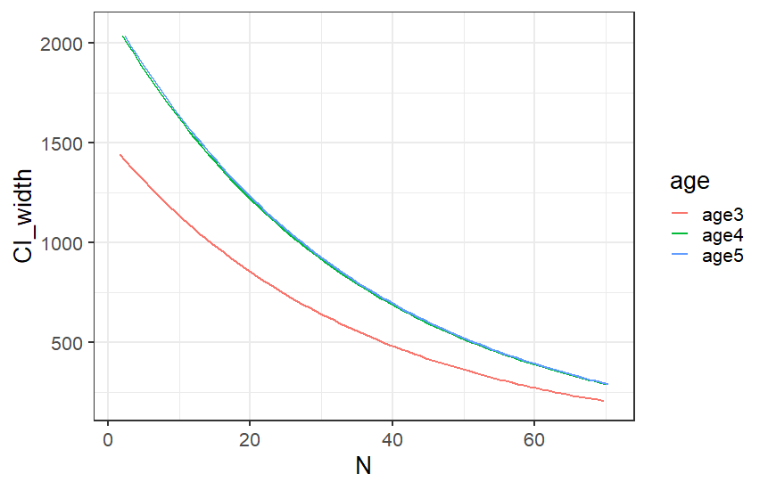

Distribution of POH lengths by age from Stamp river escapement biosamples and broodstock collections:

